 

**Placement Empowerment Program**

***Cloud Computing and DevOps Centre***

**DAY 13 TASK:**

Deploy a Web Application on the CloudWrite a Python Flask application and deploy it on your cloud VM. Configure the firewall to allow HTTP traffic.

Name:Shahana.M.S Department: ADS



**Introduction**

Deploying a web application on the cloud allows for global accessibility, scalability, and enhanced performance. Flask, a lightweight Python web framework, is commonly used for building and deploying web applications. By hosting a Flask app on a cloud-based Virtual Machine (VM), users can access the application via the internet. Configuring the firewall to allow HTTP traffic ensures that users can interact with the web application securely.

**Objective**

* To develop a basic Python Flask web application.
* To deploy the Flask application on a cloud VM (AWS, Azure, or GCP).
* To configure the cloud firewall to allow HTTP traffic (port 80).
* To test the deployed application via a public URL or IP address.

**Importance**

* **Scalability**: Hosting on the cloud allows for easy scaling based on traffic demands.
* **Accessibility**: The application can be accessed from anywhere with an internet connection.
* **Security**: Configuring firewall rules ensures controlled access to the application.
* **Cost-Effective**: Running a lightweight Flask app on a VM is an affordable hosting solution.

**STEP-BY-STEP OVERVIEW:**

Step 1: Go to AWS Management Console.

Step 2: Launch EC2 instances with Ubuntu and leave the rest as it is.

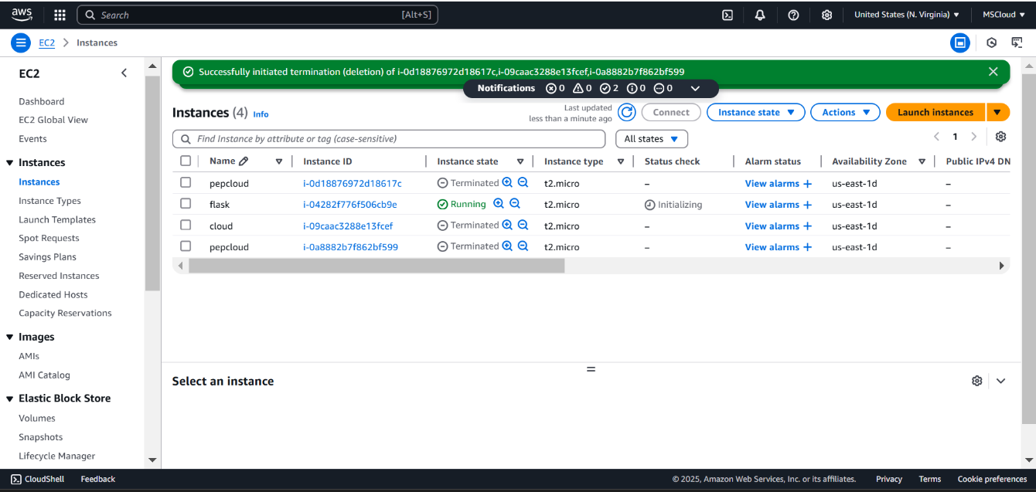

Step 3: select connect and copy the command below

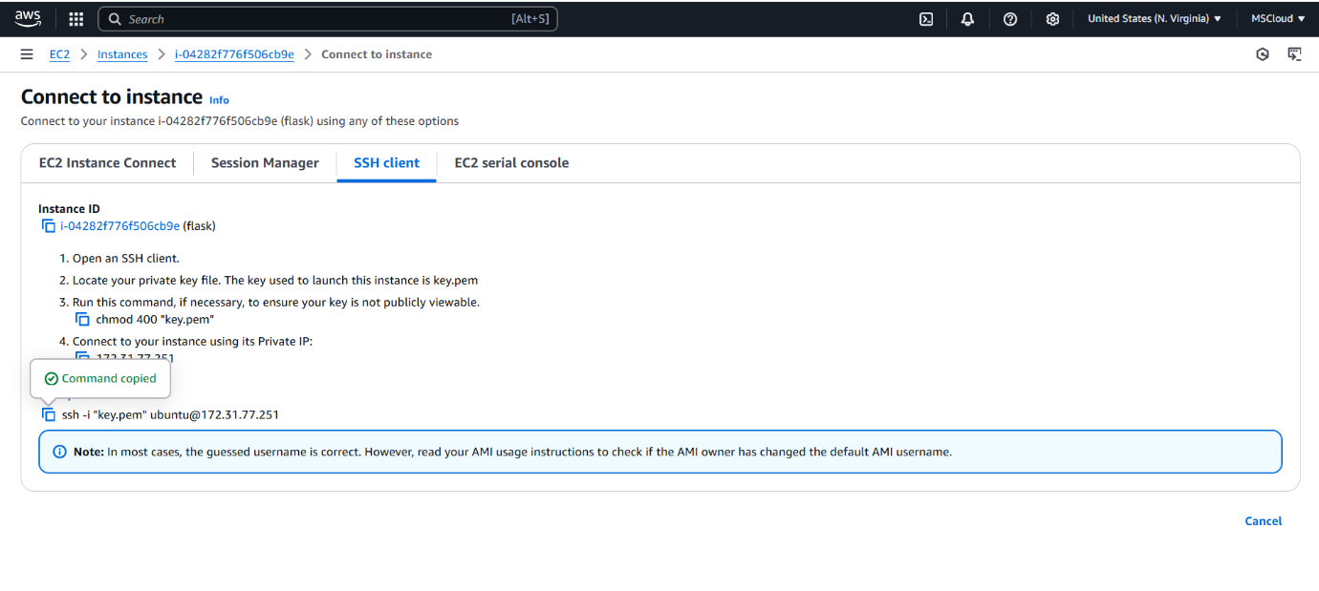

Step 4: Change the path by using cd to navigate to downloads and then paste the url copied.



Step 5: Update the Package List



Step 6: Install Python3 and pip



Step 7: install python3 by using sudo apt-get



Step 8: Create and Activate a Virtual Environment and install Flask.

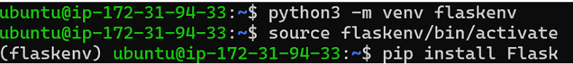

Step 9: this is to create an app and nano is a file here



Step 10: Write the below code and Ctr+X for exiting and Ctr+O for writing out

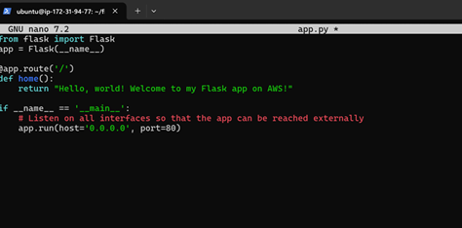

Step 11: Exit the virtual environment.



Step 12: This is said to be code to install flask



Step 13: Your Flask app is now running!

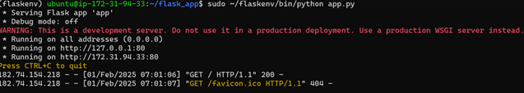

Step 14: Go to the EC2 Dashboard > Instances. Find your instance and note the Security Group attached to it.

Navigate to Security Groups under the Network & Security section. Select the Security Group associated with your EC2 instance.

Under the Inbound Rules tab, ensure there is a rule for HTTP (port 80): Type: HTTP Protocol: TCP Port Range: 80 Source: Anywhere (0.0.0.0/0, ::/0) If there isn't an HTTP rule, click Edit inbound rules and add it.

Step 15: Open your browser and navigate to: http:/// Replace with the Public IPv4 address of your EC2 instance (e.g., http://54.123.45.67/). Public IPv4 address can be found in your Ec2 instance dashboard.

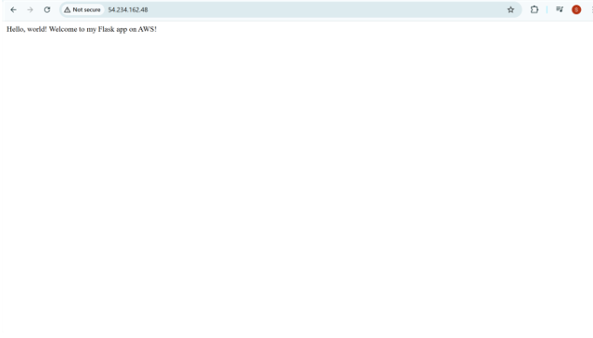

**Outcome**

* Successfully deploying a Python Flask web application on a cloud VM.
* Configuring the firewall to allow public HTTP access.
* Running and accessing the web application using a public IP or domain.
* Understanding basic cloud deployment and network security configurations.